🔄 Transaction Controller in JMeter



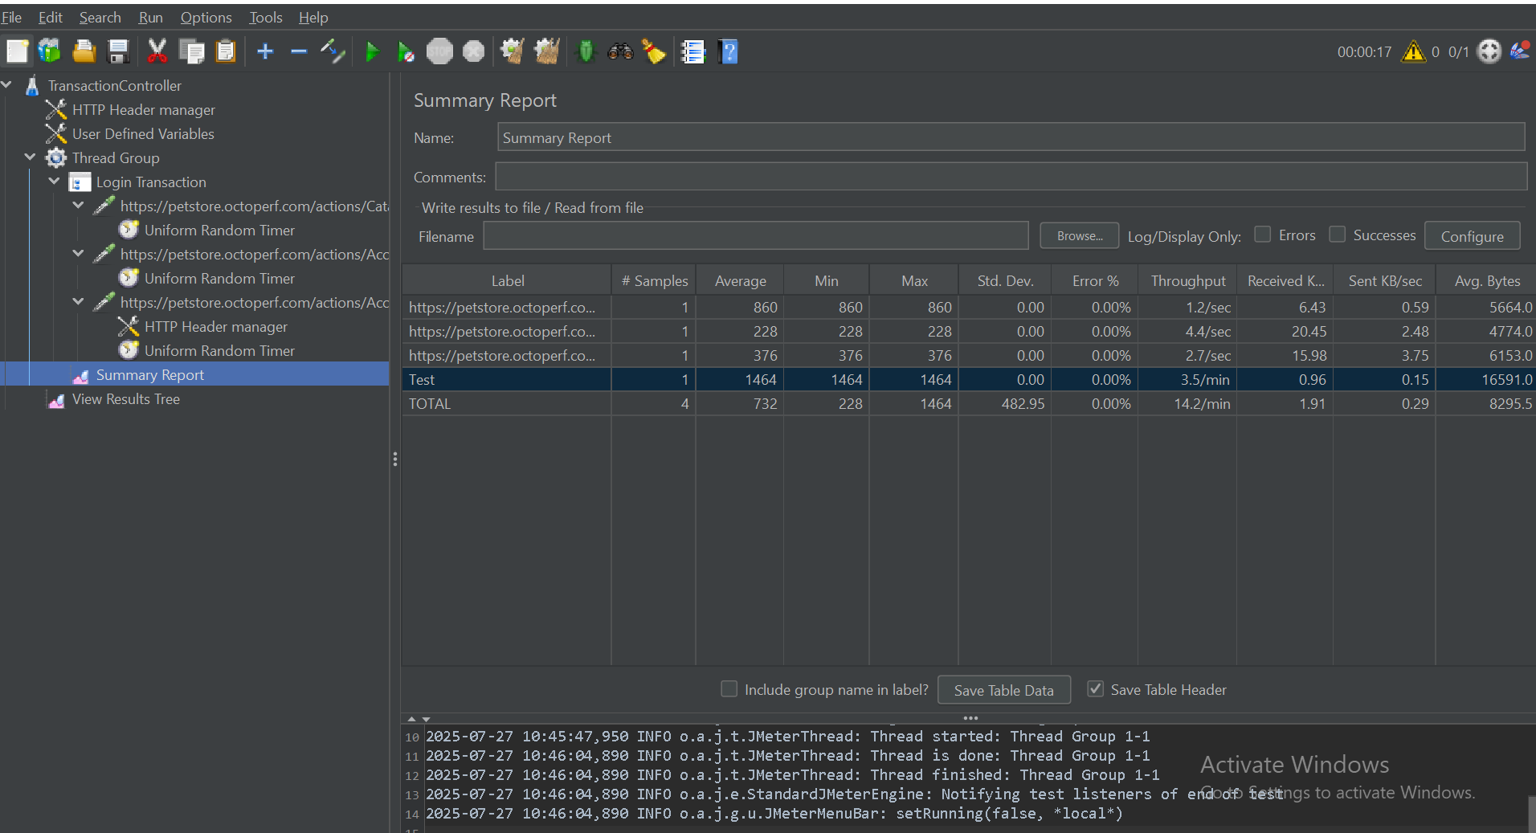

The **Transaction Controller** is a powerful Logic Controller in Apache JMeter used to **group a sequence of requests (Samplers)** and **measure the total time** taken for the entire group to execute. It is ideal for **simulating and reporting on complete business transactions** rather than individual HTTP requests.

**🎯 Why Use the Transaction Controller?**

**📌 Real-World Example**

Consider this typical user journey:

* Login
* Search for a product
* Add product to cart
* Proceed to checkout

Each step may involve **multiple HTTP requests**. Measuring them individually may not reflect the **true user experience**. Instead, grouping them using the Transaction Controller gives you the **total transaction time**, which is more useful for:

* **Business-level performance reporting**
* **Bottleneck identification**
* **Test plan organization**

**🧩 Key Benefits**

| **Feature** | **Description** |
| --- | --- |
| ✅ **End-to-End Timing** | Measures total duration for grouped requests |
| 📊 **Clear Reporting** | Appears as a single entry in listeners like Aggregate Report |
| 📁 **Logical Grouping** | Makes test plans easier to manage and understand |
| 📉 **Business Process Insight** | Lets you analyze real user workflows, not just individual hits |

**⚙️ Configuration Options**

When you add a Transaction Controller (Right-click > Add > Logic Controller > Transaction Controller), you’ll configure:

**1. Name**

* Use descriptive names like:
  + 01_Login_Transaction
  + 02_SearchProduct
  + 03_CheckoutFlow

🔢 Use numbering to help organize reports in logical order.

**2. Generate Parent Sample**

| **Setting** | **Description** |
| --- | --- |
| ✅ **Checked (Default)** | A single parent sample is generated. Total time includes all child samplers. Recommended for reporting. |
| ❌ **Unchecked** | No parent sample is shown. Only individual requests appear. Not recommended for transaction timing. |

**3. Include duration of timer and pre/post processors**

| **Setting** | **Description** |
| --- | --- |
| ✅ **Checked (Default)** | Includes time from Timers, Pre-Processors, and Post-Processors in the total transaction duration. Recommended for realistic timing. |
| ❌ **Unchecked** | Excludes that time. Only sampler execution time is included. Useful for isolating backend response time. |

**📐 How to Use It**

**🔧 Sample Structure**

pgsql

CopyEdit

Test Plan

└── Thread Group

├── Transaction Controller: 01_Login

│ ├── HTTP Request: Load Login Page

│ ├── HTTP Request: Submit Login

│ └── Assertion: Check Login Success

├── Constant Timer (2000 ms)

├── Transaction Controller: 02_Search Product

│ ├── HTTP Request: Load Search Page

│ └── HTTP Request: Execute Search

├── Constant Timer (1000 ms)

└── Transaction Controller: 03_Add to Cart

├── HTTP Request: Add Item

└── Assertion: Verify Cart Update

**📝 Usage Tips**

* Place relevant **Samplers, Assertions, Extractors, Timers** inside the Transaction Controller.
* Each Transaction Controller represents one **end-to-end user activity**.

**📈 Reporting & Analysis**

**✅ View Results Tree**

* Shows:
  + Individual Samplers
  + Parent Transaction sample (if enabled)

**✅ Aggregate Report / Summary Report**

* Transaction Controllers appear as separate entries
* Metrics shown:
  + **Min / Max / Avg response times**
  + **Throughput**
  + **Error rate**

**🚨 Important Considerations**

**🔄 Nesting**

* Transaction Controllers can be **nested**.
* Useful for representing sub-processes (e.g., inside a Checkout process).
* Be cautious with parent sample settings to avoid **double-counting durations**.

**🧾 Naming Convention**

* Use clear and consistent names.
* Add numeric prefixes for proper sorting in reports.

**❌ Error Handling**

* If any **child sampler fails**, the entire Transaction sample is marked **failed**.
* This is intentional—realistically, if any part of a transaction fails, the business operation fails.

**⏱ Timers Placement**

| **Inside Controller** | **Included in transaction time** |
| --- | --- |
| ✅ Inside | Reflects user think time within flow |
| ❌ Outside | Represents pause between business processes |

**🧠 Best Practices**

| **Tip** | **Why** |
| --- | --- |
| ✔️ Enable "Generate Parent Sample" | Crucial for accurate transaction timing |
| ✔️ Include Timers | For realistic UX simulation |
| 🚫 Avoid unnecessary nesting | Simplifies test plan and avoids confusion |
| 🔍 Use Debug Sampler during dev | Validate timing and variable extraction |
| 🔢 Use numerical prefixes in names | Sorts transactions in report-friendly order |

**✅ Summary**

| **Feature** | **Benefit** |
| --- | --- |
| 🧮 **Aggregates child sampler timings** | Simulates full business transaction |
| 📦 **Organizes complex flows** | Easier to manage and report |
| 📊 **Shows up in key reports** | Better for performance analysis |
| 🧭 **Guides optimization** | Helps identify slow processes |
| 👨‍💼 **Business-friendly** | Matches how real users interact with apps |